**Cairo University**

**Faculty of Computers and Artificial Intelligence**

**Information Systems Department**

**Graduation Project Report**

**Green**

By

|  |  |
| --- | --- |
| **ID** | **Name** |
| **20190215** | **Zeyad Ahmed Hamed Mohamed** |
| **20190441** | **Mohamed Samy Elgabry** |
| **20190177** | **Hassan Ragab Hassan Bakr** |
| **20190335** | **Alaa Sabry Mohamed** |
| **20190412** | **Mohsen Mohamed Mahmoud** |

**Under the Supervisors of:**

**Dr. Laila Abdel Rahman**

**TA. Eng. Nourhan Hussein**

Academic Year 2022-2023

*Department of Information Systems, Faculty of Computers and Artificial Intelligence, Cairo University, Egypt*

**Abstract**

The “Green” project is an application that aims to raise awareness about the importance of preserving the environment and provide tools and resources to help individuals and communities do their part. The platform allows users to book trusted gardeners and shop for environmentally friendly products, making it easier for them to embrace a greener lifestyle and contribute to the well-being of our planet. In addition to these features, Green also includes Expert Advisors who can provide personalized advice and recommendations, and have recommendation systems that provide helpful features to users based on their preferences and needs, Plant Care Recommendations to help users keep their plants healthy and thriving, and Reminders to help them stay on track with their sustainability goals. By leveraging the latest technologies and best practices, Green is balanced to become a valuable and relevant resource for those looking to make a positive impact on the environment.

**Table of Contents**

## Contents

Contents 3

**Chapter 1: Introduction** 6

**1.1 Background and Motivation** 6

**1.2 Problem Statement** 7

**1.3 Solution Statement** 7

**1.4 Objectives** 8

**1.5 Project Scope** 8

**1.6 Project Limitations** 9

**1.7 Work Plan** 10

**1.8 Project Methodology** 10

**1.10 Project Report Outline** 11

**Chapter 2 Market and Literature Survey** 12

**2.1 Related Work** 12

**2.2 SWOT Analysis** 13

**2.3 Functional Requirements** 15

**2.4 Non-functional Requirements** 18

**Chapter 3 “Green” Analysis** 20

**3.1 Use Case Model** 20

3.1.1 Use Case Diagram 20

3.1.2 Use Case Descriptions 22

**3.2 System Architecture** 33

**3.3 Sequence Diagrams** 34

**3.4 Data Flow Diagram** 39

**3.5 Class Diagram** 44

**3.6 ER Diagram** 45

**3.7 Package Diagram** 46

**3.8 Database Schema** 47

**3.9 Activity Diagram** 48

**Chapter 4 “Green” Design** 50

**4.1 System prototype screens** 50

**4.2 Tools & Techniques** 54

**Chapter 5 Conclusions and Future Work** 55

**5.1 Conclusions** 55

**5.2 Future Work** 55

**List of Figures**

Figure 1 Work plan 1 10

Figure 2 Work plan 2 10

Figure 3 Customer Use case 20

Figure 4 Gardener Use case 21

Figure 5 Advisor Use case 22

Figure 6 System Architecture 33

Figure 7 Sequence 1 34

Figure 8 Sequence 2 34

Figure 9 Sequence 3 35

Figure 10 Sequence 4 35

Figure 11 Sequence 5 36

Figure 12 Sequence 6 37

Figure 13 Sequence 7 37

Figure 14 Sequence 8 38

Figure 15 Sequence 9 38

Figure 16 Sequence 10 39

Figure 17 Data Flow 1 39

Figure 18 Data flow 2 40

Figure 19 Data flow 3 41

Figure 20 Data flow 4 42

Figure 21 Data flow 5 42

Figure 22 Data flow 6 43

Figure 23 Data flow 7 43

Figure 24 Class Diagram 44

Figure 25 ERD 45

Figure 26 Package diagram 46

Figure 27 Database Schema 47

Figure 28 Activity Diagram 1 48

Figure 29 Activity Diagram 2 49

**List of Tables**

Table 1 Related work 12

Table 2 Use Case Description 1 22

Table 3 Use Case Description 2 23

Table 4 Use Case Description 3 24

Table 5 Use Case Description 4 24

Table 6 Use Case Description 5 25

Table 7 Use Case Description 6 26

Table 8 Use Case Description 7 27

Table 9 Use Case Description 8 27

Table 10 Use Case Description 9 28

Table 11 Use Case Description 10 29

Table 12 Use Case Description 11 29

Table 13 Use Case Description 12 30

Table 14 Use Case Description 13 31

Table 15 Use Case Description 14 31

# **Chapter 1: Introduction**

## **1.1 Background and Motivation**

Welcome to “Green”, a new and innovative application that aims to raise awareness about the importance of preserving our environment and providing tools and resources to help individuals and communities do their part. Whether you are looking to book a gardener or shop for environmentally friendly products, Green has you covered. Our goal is to make it easier for everyone to embrace a greener lifestyle and contribute to the well-being of our planet.

As the world continues to struggle with the effects of climate change, it is more important than ever that we all do our part to protect and preserve our environment. From reducing waste and energy consumption to planting trees and supporting sustainable practices, there are many ways that we can make a difference.

But sometimes it can feel overwhelming to know where to start or how to make a real impact. That's where Green comes in. By providing a platform for booking skilled gardeners and shopping for eco-friendly products, we hope to make it easier for individuals and communities to act and make a positive difference.

We believe that by working together, we can create a brighter, more sustainable future for all. Join us on this journey by downloading Green today and start making a difference in your own backyard.

## **1.2 Problem Statement**

Many people may want to adopt more sustainable practices, but they may not know where to start or how to find reliable resources. Additionally, there is often a lack of transparency and accountability in the eco-friendly products industry, making it difficult for consumers to make informed decisions about the products they buy, and the limited access to reliable and trustworthy gardeners. The problem of climate change and pollution is one of the greatest challenges facing humanity today. The impacts of rising temperatures, extreme weather events, and air and water pollution are already being felt around the world, with devastating consequences for people, wildlife, and the environment. Despite the urgent need for action, many individuals and communities are still struggling to access the resources and information they need to make a meaningful difference.

## **1.3 Solution Statement**

Our goal is to make it easier for individuals and communities to access the resources and information they need to adopt more sustainable practices and reduce their environmental impact. Through our platform, users can connect with skilled professionals who can help them create and maintain beautiful, eco-friendly gardens, and shop for products that are made with sustainable materials and processes. Additionally, Green provides resources and information to help users understand the importance of preserving our planet and how they can make a difference. By working together, we can create a brighter, more sustainable future for all.

## **1.4 Objectives**

“Green” aims to:

* Raise awareness about the importance of preserving the environment and provide resources and information to help individuals and communities adopt more sustainable practices.
* Provide a solution by offering a platform for booking trusted gardeners.
* Shopping for high-quality, environmentally friendly products.
* Expert Advisors who can provide personalized advice and recommendations.
* Plant Care Recommendations to help users keep their plants healthy and thriving.
* Reminders to help them stay on track with their sustainability goals.

By offering these tools and resources, “Green” aims to make it easier for individuals and communities to embrace a greener lifestyle and contribute to the well-being of our planet.

## **1.5 Project Scope**

* Providing a platform for booking trusted gardeners and shopping for environmentally friendly products.
* Offering Expert Advisors who can provide personalized advice and recommendations, Plant Care Recommendations to help users keep their plants healthy and thriving, and Reminders to help them stay on track with their sustainability goals.
* Providing educational resources and information to help users understand the importance of preserving our planet and how they can make a difference.
* Foster a sense of community and encourage collaboration among users, encouraging them to share ideas, resources, and best practices for preserving the environment.

## **1.6 Project Limitations**

* Limited data: Limited access to reliable and trustworthy gardeners and eco-friendly products (we only try we not trust in it as a beginning).
* Limited knowledge and understanding among users about the importance of preserving the environment and how to adopt more sustainable practices.
* Limited financial resources to invest in marketing and outreach efforts to raise awareness about the “Green” system.
* Limited reach and influence in areas where access to technology or internet connectivity may be limited.
* Limited ability to predict and respond to changing user needs and preferences over time, due to cultural or social differences in the Egyptian market.
* Limited ability to control or regulate the quality or authenticity of products or services offered by third-party vendors or providers.
* Maintenance : After a failure, corrective maintenance is performed

Or as Deferred Corrective Maintenance

## **1.7 Work Plan**

Figure Work plan 1

Figure Work plan 2

## **1.8 Project Methodology**

**Agile (Extreme Programing)**

XP emphasizes a collaborative, team-based approach to development, with a strong focus on communication, feedback, and continuous improvement. The methodology involves working in short iterations, often referred to as "sprints," typically lasting one to two weeks. During each sprint, the team focuses on delivering a set of working software features that are prioritized by the customer or product owner.

XP places a strong emphasis on software engineering practices, such as test-driven development (TDD), pair programming, continuous integration, and frequent releases. These practices are intended to help the team catch and fix defects early in the development process, reduce the risk of regression, and ensure that the software is of high quality and meets customer requirements.

## **1.10 Project Report Outline**

The rest of this report is organized as follows: In Chapter 2 Representations of related work are provided, In Chapter 3 the Green Application Analysis is provided, In Chapter 4 Green Application Design and Implementation is provided, In Chapter 5 Green Application Testing and Evaluation is provided, In Chapter 6 Conclusions and Future Work are provided.

# **Chapter 2 Market and Literature Survey**

## **2.1 Related Work**

Table Related work

|  |  |  |  |
| --- | --- | --- | --- |
| Application | Platform | target | Features |
| Garden Tags | Available on iOS and Android. | Educational and management app | Through this app, Keep a collection of images of your plants and gardens in one handy location.  Identify unknown plants with the help of an entire gardening community at your fingertips.  Set up a plant care task to-do list  Get advice from a community of gardeners |
| Gardroid | Available on Android. | Are those carrots ripe? To assist you in harvesting your crops, this gardening app offers helpful information about the processes of vegetable cultivation. | Plant care tips.  Progress tracking for your vegetables.  Journal space to add your own notes.  Recommended harvesting periods for each plant.  Sowing tips and information. |
| Alyaseen Argi | Website | Home gardeners, Professional Gardeners, Agricultural business | A website for users who want to purchase supplies for their own gardeners.  A wide selection of high quality products. |
|  |  |  |  |

Compared to previous, we go one better in these features:

* Raise awareness about the importance of preserving the environment and provide resources and information to help individuals and communities adopt more sustainable practices.
* Provide a solution by offering a platform for booking trusted gardeners.
* Shopping for high-quality, environmentally friendly products.
* Expert Advisors who can provide personalized advice and recommendations.
* Plant Care Recommendations to help users keep their plants healthy and thriving.
* Reminders to help them stay on track with their sustainability goals.

## **2.2 SWOT Analysis**

**Strengths:**

* Innovative solution: Green provides a unique platform for booking gardeners and shopping for eco-friendly products, making it easier for individuals and communities to adopt sustainable practices.
* Personalized advice: Expert Advisors offer personalized advice and recommendations to users, helping them make informed decisions about their environmental impact.
* Access to resources: Green provides educational resources and information to help users understand the importance of preserving the environment and how they can make a difference.
* Sense of community: The platform fosters a sense of community among users, encouraging them to share ideas, resources, and best practices for preserving the environment.

**Weaknesses:**

* Limited access to reliable gardeners and eco-friendly products: This can be a challenge for users who want to make a difference but are unable to find reliable resources.
* Limited knowledge and understanding among users: Many people may be unaware of the importance of preserving the environment and the steps they can take to reduce their impact.
* Limited marketing and outreach efforts: The project may face financial constraints and limited reach in areas with limited access to technology or internet connectivity.

**Opportunities:**

* Growing awareness about climate change: As people become more aware of the impact of climate change, there may be an increased demand for resources and tools to help them adopt sustainable practices.
* Expansion into new markets: With a growing demand for eco-friendly products, there may be opportunities to expand the platform into new markets and reach a wider audience.
* Increased partnerships with third-party vendors: By partnering with trusted vendors and providers, Green can expand its offerings and better meet the needs of users.

**Threats:**

* Competition from similar platforms: As more companies enter the market, Green may face increased competition and need to differentiate to stay ahead.
* Changing user needs and preferences: There may be changes in user needs and preferences over time, which could make it challenging for the platform to keep up with the changing market.
* Regulation and control issues: There may be challenges in regulating the quality and authenticity of products and services offered by third-party vendors, which could impact on the platform's reputation.

## **2.3 Functional Requirements**

|  |  |
| --- | --- |
| Priority | Description |
| 1 | Critical Requirements that without it the program will not function well |
| 2 | Important Requirements that make the project more usable for users |
| 3 | A Good feature to have if there is enough time |

Functional Requirements for Authentication and Authorization:

* User Registration: Users must be able to create an account on the Green platform by providing a unique username, email address, and password.
* Login: Users must be able to log into their Green account using their email address and password.
* Forgotten Password: Users must be able to reset their password in case they forget it by providing their email address.
* User Profile: Users must be able to view and edit their profile information, including their name, email address, and password.
* Role-based Access: The Green platform must support different user roles, such as gardeners, product vendors, and regular users, with each role having different levels of access to the platform's features and resources.
* Authorization Checks: The Green platform must perform authorization checks for each user action to ensure that users can only access resources and features that they are authorized to access.
* Session Management: The Green platform must manage user sessions to ensure that users remain logged in for a specified duration or until they log out.
* Logout: Users must be able to log out of their Green account at any time.
* Security: The Green platform must implement secure authentication and authorization mechanisms, such as encryption, to protect user data and prevent unauthorized access.

1. User Management:

* Ability to create and manage user accounts.
* Option for users to sign up using their social media account.
* Ability for users to update their personal information.
* Support for password recovery

1. Gardener Booking:

* Ability for users to search for and view available gardeners based on their location.
* Option for users to book a gardener for a specific date and time.
* Ability to provide feedback and ratings for gardeners.
* Ability to view past bookings and reschedule or cancel existing bookings.

1. Eco-friendly Products:

* Ability to browse and search for a variety of eco-friendly products.
* Option to view product details and specifications.
* Ability to purchase products directly through the platform.
* Option to leave a review and rating for products.
* Ability to view past purchases and order history.

1. Expert Advisors:

* Ability to connect with an expert advisor for personalized advice and recommendations.
* Option to schedule a call or chat session with an expert advisor.
* Ability to view previous conversations and schedules.

1. Plant Care Recommendations:

* Ability to receive tailored recommendations for plant care based on the type and location of the plant.
* Option to receive reminders for watering and fertilizing plants.
* Ability to view past recommendations and track the progress of plants.

1. Reminders:

* Ability to set reminders for specific tasks related to sustainability goals.
* Option to receive reminders via push notifications or email.
* Ability to view and manage reminders in a calendar view.

1. Educational Resources:

* Ability to access and view a variety of educational resources and information related to preserving the environment.
* Option to save and bookmark resources for later use.

1. Community Collaboration:

* Ability to connect with other users and share ideas and resources.
* Option to join or create groups focused on specific sustainability topics.
* Ability to view and participate in community events and initiatives.

## **2.4 Non-functional Requirements**

1. **Performance:**
   * The platform should be fast and responsive, with quick load times and minimal downtime.
   * The system should be able to handle a high volume of traffic and user interactions without impacting performance.
2. **Scalability:**
   * The system should be designed to accommodate future growth and expansion, with the ability to scale up or down as needed.
   * The platform should be able to handle an increase in users and features over time.
3. **Security:**
   * The platform should protect user data and information, ensuring that it is secure and confidential.
   * The system should be designed to prevent unauthorized access and protect against cyber threats.
4. **Usability:**
   * The platform should be user-friendly, with a intuitive and accessible interface that makes it easy for users to find what they need.
   * The system should be designed to accommodate users with different levels of technical expertise.
5. **Compatibility:**
   * The platform should be compatible with a variety of devices and platforms, including desktop, mobile, and tablet.
   * The system should be able to integrate with other existing tools and systems.
6. **Reliability:**
   * The platform should be reliable and dependable, with minimal downtime and disruptions.
   * The system should be designed to withstand failures and be able to recover quickly.
7. **Maintenance:**
   * The platform should be designed to minimize maintenance and support costs, with an efficient and streamlined process for updating and fixing bugs.
   * The system should be designed to be easy to manage and maintain overtime.

# **Chapter 3 “Green” Analysis**

## **3.1 Use Case Model**

### 3.1.1 Use Case Diagram

Figure Customer Use case

Figure Gardener Use case

Figure Advisor Use case

### 3.1.2 Use Case Descriptions

Table Use Case Description 1

|  |  |
| --- | --- |
| ID | UC_1 |
| Title | Registration |
| Description | the new users must register in the application by entering email, username, and password in addition to his expected domain, and for gardeners, experts they should fill an application that will be accepted by the admins. |
| Primary Actor | All Users and System. |
| Preconditions | --------- |
| Postconditions | The User will be successfully registered on the application. |
| Main Success Scenario | 1-[User] Enters his details  2-[System] Verify User  3-[System]Add the user to the database |
| Extensions | 1-[System] if the user writes unacceptable password an error will be shown.  2-[System] All information must be entered by the user so the system can register him. |
| Frequency of use | Only Once |
| Priority | 1 |

Table Use Case Description 2

|  |  |
| --- | --- |
| ID | UC_2 |
| Title | Login |
| Description | The Users will enter their existing email and password to login to the application. |
| Primary Actor | All Users and System. |
| Preconditions | Registering on the application. |
| Postconditions | The User will successfully login to the system. |
| Main Success Scenario | 1-[User] Enters his email and password  2-[System]Verifies his email and password  3-[User]will access all system functionalities |
| Extensions | 1-“Try Again” is a message that will appear if the password or email is incorrect.  2-“User not Available” is a message that will appear if the user is not registered in the application. |
| Frequency of use | Whenever the User enters the application. |
| Priority | 1 |

Table Use Case Description 3

|  |  |
| --- | --- |
| ID | UC_3 |
| Title | Add User Domain |
| Description | Whenever a user register on the system he must enter his Domain of search, the expected budget, the area of his garden, so the system can recommend to him things near to his domain. |
| Primary Actor | Customer and System. |
| Preconditions | Registering on the application. |
| Postconditions | The User will Successfully login to the system. |
| Main Success Scenario | 1-[User] Enters his domain information.  2-[System] Check if data is entered correctly.  3-[System] User can then login to the system. |
| Extensions | 1-“Incorrect Format” message if the user enters data in different format.  2-“Data missing” message if user didn’t full all the required information. |
| Frequency of use | Only once. |
| Priority | 1 |

Table Use Case Description 4

|  |  |
| --- | --- |
| ID | UC_4 |
| Title | Check Recommended Items |
| Description | After the user log into the system and choose ‘Shop for items’ there will be a part containing the recommended items for him based on the data he entered while registering to the system. |
| Primary Actor | Customer and System |
| Preconditions | Click on ‘Shop for products’ |
| Postconditions | The User can then Buy directly from the recommended items if he found what he is searching for or return to the all products. |
| Main Success Scenario | 1-[User] Login to system.  2-[User] click on ‘shop for products’  3-[System]a part of the page will contain the recommended items will be shown to him |
| Extensions | Bad internet connection may not help to show the user the exactly recommended items. |
| Frequency of use | Whenever the Customer enters ‘Shop for items’ |
| Priority | 2 |

Table Use Case Description 5

|  |  |
| --- | --- |
| ID | UC_5 |
| Title | Shop for items |
| Description | The application has a green store which contains Eco-friendly products that meet user needs and considering that the products will not be harmful to the environment, in addition to that based on the domain of the user(which he entered in registration step) the system will recommend for the user products similar to his capabilities and requirements. |
| Primary Actor | Customer and System |
| Preconditions | Login to System |
| Postconditions | The User can then Search for what he needs, place orders, view, update his shopping cart |
| Main Success Scenario | 1-[User] Login to system.  2-[User]Click on “Shop for items” and search for what he needs and place orders  3-[System]Verify the orders and data of the user. |
| Extensions | 1-“Out of stock” the product the user is trying to buy is out of stock.  2-“Data is missing” the user didn’t write his complete information like the address and mobile number while placing order.  3-Bad internet connection as placing orders will require internet connection. |
| Frequency of use | Whenever the User wish to buy products |
| Priority | 2 |

Table Use Case Description 6

|  |  |
| --- | --- |
| ID | UC_6 |
| Title | Book a Gardener |
| Description | The application has a feature the make the user can search for and book a gardener. And the availability to give feedback and ratings to them so all customers can enjoy a unique experience without any problems |
| Primary Actor | Customer, Gardener, and System |
| Preconditions | Login to System |
| Postconditions | The User can then get in contact with the gardener(Chat or Phone) he booked if he accepted the request to manage how the things will work |
| Main Success Scenario | 1-[User] Login to system.  2-[User]Click on “Book a Gardener.”  3-[System] will show to user the available gardeners and their ratings, reviews.  3-[User]the User will book the suitable gardener and wait for the gardener to accept the request. |
| Extensions | 1- the Customer didn’t rate the gardener as this important so other users can have a unique experience without any problems.  2-the Customer or user added wrong personal information as the phone number, this will cause a problem in the connection between the gardener and the customer.  3-Bad internet connection. |
| Frequency of use | Whenever the User wish book a gardener |
| Priority | 2 |

Table Use Case Description 7

|  |  |
| --- | --- |
| ID | UC_7 |
| Title | Chat with expert advisor |
| Description | The application has a feature the make the user get in contact with an expert advisor to answer all the questions that the user needs answers for them in the field of agricultural and plants |
| Primary Actor | Customer, Expert advisor, and System |
| Preconditions | Login to System |
| Postconditions | The User can then find the answers for all his inquires and questions. |
| Main Success Scenario | 1-[User] Login to system.  2-[User]Click on “Chat with expert advisor.”  3-[System]will allow the user to chat with the advisor he wants, and wait for the advisor to accept his request. |
| Extensions | 1-Misunderstanding between the customer and the advisor so the chat must be clear and understandable.  2-Bad internet connection. |
| Frequency of use | Whenever the User wish to find answers for his inquires in the agricultural field. |
| Priority | 2 |

Table Use Case Description 8

|  |  |
| --- | --- |
| ID | UC_8 |
| Title | Check Reminder |
| Description | The application has a feature that allow the user to set reminders for his plant caring plans as reminder to water them, put fertilizers, cut them, fixing time. |
| Primary Actor | Customers and System |
| Preconditions | Login to System |
| Postconditions | The Users will always take care of their plants and make it easier for them to maintain their plants and not let them die. |
| Main Success Scenario | 1-[User] Login to system.  2-[User]Click on “Reminders.” Then set reminders for what he wishes.  3-[System]will save these reminders and send notifications to the user at the reminders time. |
| Extensions | 1-The user forget to save the reminders he set.  2-The user didn’t enable the notification from our app in his phone settings. |
| Frequency of use | Whenever the User wish set reminders to care after his plants. |
| Priority | 2 |

Table Use Case Description 9

|  |  |
| --- | --- |
| ID | UC_9 |
| Title | View Tips |
| Description | The application has a feature that provide the users with information about how to take care of their plants and make them grow faster and better in addition to information about how to contribute in saving the environment and reduce their environmental impact. |
| Primary Actor | User and System |
| Preconditions | Login to System |
| Postconditions | The Users will then have information on how they will take care after their plants and how preserve the environment. |
| Main Success Scenario | 1-[User] Login to system.  2-[User]Click on “View plant care/ environment recommendations”.  3-[System]the system will provide the user with the information he requested. |
| Extensions | ------ |
| Frequency of use | Whenever the User wish to learn about plant caring and how to decrease his environmental impact. |
| Priority | 2 |

Table Use Case Description 10

|  |  |
| --- | --- |
| ID | UC_10 |
| Title | Learn about plants |
| Description | The application has a feature that provide the users with information to help them to learn more about plants and it types, diseases, sizes, colors, etc. and to search for specific plant to learn more about it. |
| Primary Actor | Customer and System |
| Preconditions | Login to System |
| Postconditions | The Users will then have knowledge about the plant’s environment. |
| Main Success Scenario | 1-[User] Login to system.  2-[User]Click on “Learn about plant”.  3-[System]the system will provide the user with the information he requested. |
| Extensions | The user searches for plant that doesn’t exist. |
| Frequency of use | Whenever the User wish to increase his knowledge in the plants environment or to know the specification of particular plant. |
| Priority | 2 |

Table Use Case Description 11

|  |  |
| --- | --- |
| ID | UC_11 |
| Title | Manage Profile |
| Description | The different type of users can update their personal information, the Customer also can update his domain, the Gardeners can update their availability time for example. |
| Primary Actor | Customers, Gardeners, Expert Advisors, and System |
| Preconditions | Login to System |
| Postconditions | The Users then can change their personal information as they want. |
| Main Success Scenario | 1-[User] Login to system.  2-[User]Click on “Manage Profile”.  3-[System]the system will direct the user to his profile page so he can update his information. |
| Extensions | 1-The user enters invalid data, can’t be accepted.  2-The user didn’t fill all the required information. |
| Frequency of use | Whenever the User wish to update his personal information. |
| Priority | 1 |

Table Use Case Description 12

|  |  |
| --- | --- |
| ID | UC_12 |
| Title | Check current reservations |
| Description | The Gardeners can view and edit their bookings. they can see the date, time, and location of each booking, as well as the name and contact details of the client who booked them and a chat between them and the customer, also the Expert advisors can check the current chats with the customers |
| Primary Actor | Gardeners, Expert Advisors and System |
| Preconditions | Login to System |
| Postconditions | The Users then can manage and check their reservations. |
| Main Success Scenario | 1-[User] Login to system.  2-[User]Click on “Check current reservations”.  3-[System]the system will direct the Gardener & Expert to their bookings page so they can check and manage their reservations. |
| Extensions | 1-If the Gardener or expert have no reservations the system will show him a message to let him know that there are no current reservations.  2-Bad internet connection. |
| Frequency of use | Whenever the Gardeners or experts which to check their current reservations. |
| Priority | 2 |

Table Use Case Description 13

|  |  |
| --- | --- |
| ID | UC_13 |
| Title | View Bookings |
| Description | The Customer can check his ongoing bookings whenever he want, when gardeners and experts accept his requests he will find them in his bookings so he can get in contact with them whenever they want. |
| Primary Actor | Customers, and System |
| Preconditions | Login to System |
| Postconditions | The Customers can then get in contact with the Gardeners or experts whom he booked. |
| Main Success Scenario | 1-[User] Login to system.  2-[User]Click on “View Bookings”.  3-[System]the system will direct the Customers to a page containing the Gardeners or experts whom he booked. |
| Extensions | 1-If the Customer didn’t book any, a message “you have no current bookings” will be shown to him. |
| Frequency of use | Whenever the Customer wants to check his current bookings. |
| Priority | 1 |

Table Use Case Description 14

|  |  |
| --- | --- |
| ID | UC_14 |
| Title | Check Requests |
| Description | Green allows the advisor and gardener to access a list of pending requests for them to be booked. They review each request and the gardener have the choice to accept or reject them. |
| Primary Actor | Expert Advisors, Gardeners, and System |
| Preconditions | Login to System |
| Postconditions | The Expert advisors, Gardeners can then contact the user, either through a phone call, video call or submits their response which is reviewed by the user. |
| Main Success Scenario | 1-[User] Login to system.  2-[User]Click on “Check Requests.”  3-[System]for the gardeners if they accept the system will view to them the customer info and open a chat between them and the customers so they can get in contact.  4-[System]for experts the system will automatically create a chat between them and customers. |
| Extensions | 1-Bad internet connection from either side of them will cause a problem in the communication between them “unstable network” |
| Frequency of use | Whenever the Advisors, Gardeners which to respond to the pending request from the Customers |
| Priority | 1 |

## **3.2 System Architecture**

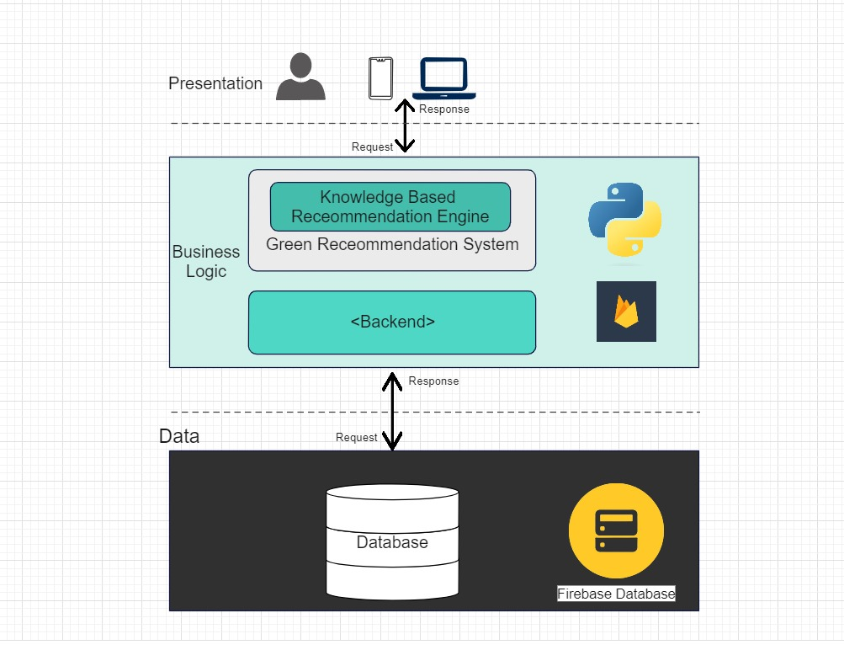

Figure System Architecture

## **3.3 Sequence Diagrams**

Figure Sequence 1

Figure Sequence 2

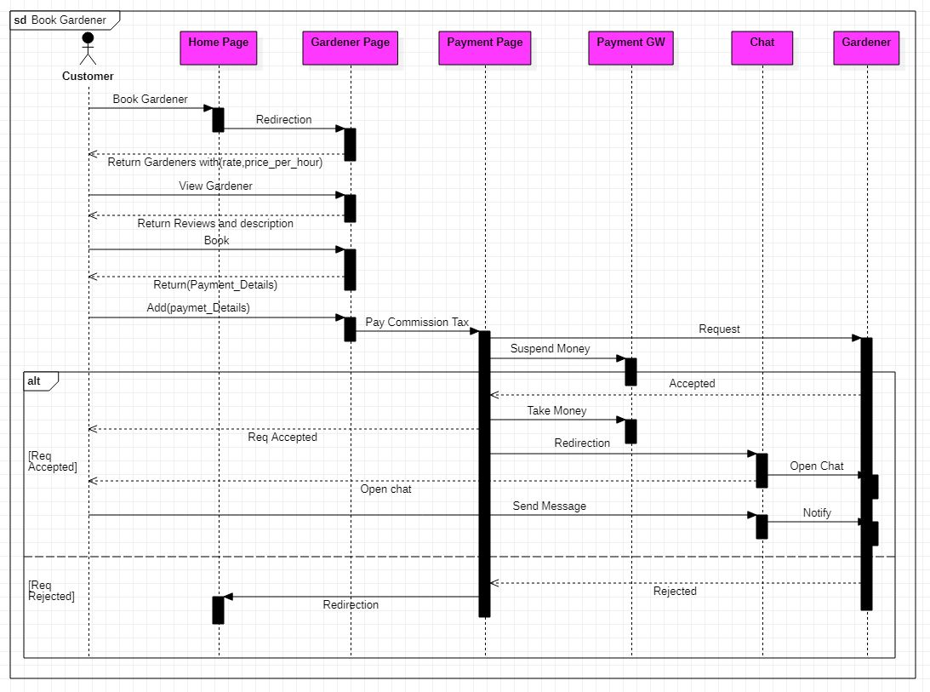

Figure Sequence 3

Figure Sequence 4

Figure Sequence 5

Figure Sequence 6

Figure Sequence 7

Figure Sequence 8

Figure Sequence 9

Figure Sequence 10

## **3.4 Data Flow Diagram**

Context diagram Data flow

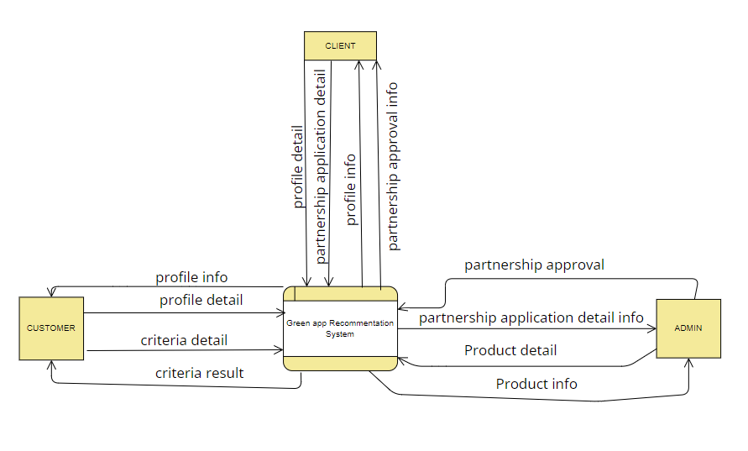

Figure Data Flow 1

Figure 3.0 Context Diagram

Figure 3.0 display the context diagram of proposed system. There are three main entities that connected to the system which are Admin, Client “expert or gardener” and Customer. Admin has four data flows. There is two outgoing data flow and two ingoing data flow. One outgoing data is application approval and the other one is product detail while ingoing data flows are partnership application detail info and product info. Customer has four data flows. There are two outgoing data flows and two ingoing data flow. Two outgoing data flows are profile detail and criteria detail while two ingoing data flows are profile info and criteria result. There are four data flows which consist of two outgoing data flows and two ingoing data flows involved Client entity. Data provided into the system by the Client are partnership application detail, profile detail, while the ingoing data flows are partnership approval info, profile info.

**Data flow diagram level 0**

Figure Data flow 2

Figure 3.1 Data Flow Diagram Level 0

Figure 3.1 shows the Data Flow Diagram of the system. There are four main activities involved in this proposed system. Those functions are Apply Partnership, Manage Profile, Manage Shop, Choose Criteria. Three main entities involved are Admin, Client (expert or gardener) and Customer. There are four different data store which are D1, D2, D3, and D4. D1 will record all data involving partnership once they request into the system and approved by admin. D2 stored all the shop details input by admin D3 is a storage for client expert or gardener) records. D4 stored customer information.

**Data flow diagram level 1**

**Partnership application client (expert or gardener)**

Figure Data flow 3

Figure 3.2 DFD L1 1.0

In figure 3.2, client input to apply partnership into apply partnership process, input to cancel partnership into cancel partnership process which output partnership details and cancel details in partnership record data store respectively. Admin receives the partnership application form and make approval process which output partnership details into D1 partnership record data store. Admin input termination status details into inactive account and terminate status in partnership record data store.

**Manage shop (Admin)**

Figure Data flow 4

Figure 3.3 Data Flow Diagram Level 1 – Manage shop for Admin.

In Figure 3.3, there are four processes involved in manage product for Admin. To add product, admin needs to insert product details. The record will be stored in product table. After that, product list will be displayed. Admin can view, delete, and update on this page. Any changes will be stored in the table.

**Manage Profile (client) ‘expert or gardener.’**

Figure Data flow 5

Figure 3.4 DFD L1 3.0

In Figure 3.4 there are four processes involved in manage profile for client. They can either Register, Update Profile, Update Password or View Profile. Client needs to register before having an access into the system. They need to provide profile detail and the detail will be stored into D3.

**Manage Profile (Customer)**

Figure Data flow 6

Figure 3.5 DFD L1 4.0

In Figure 3.5 there are four processes involved in manage profile for customer. They can either Register, Update Profile, Update Password or View Profile. Customer needs to register before having an access into the system. They need to provide profile detail and the detail will be stored into D4.

**Choose Criteria (Customer)**

Figure Data flow 7

Figure 3.6 Data Flow Diagram Level 1 – Choose Criteria for Customer

In Figure 3.6, there are three processes involved in choose criteria for customer. Customer needs to select criteria then click submit to generate shop recommendation which retrieve the shop record and criteria record. Score will be calculated, and result will be displayed

**3.5 Class Diagram**

Figure Class Diagram

## **3.6 ER Diagram**

Figure ERD

**3.7 Package Diagram**

Figure Package diagram

## **3.8 Database Schema**

Figure Database Schema

## **3.9 Activity Diagram**

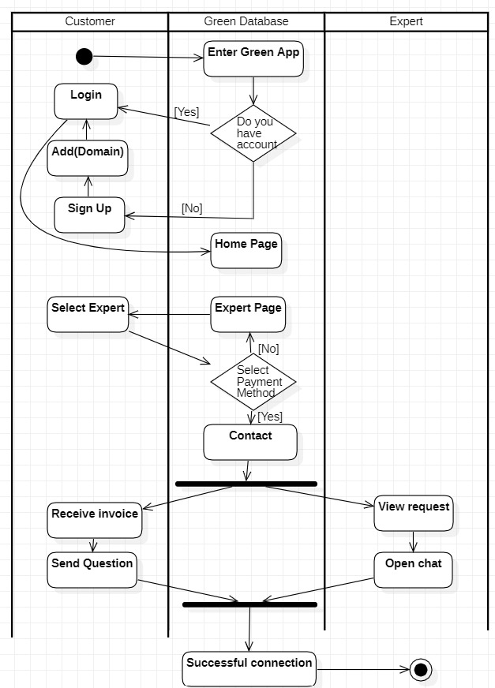

Figure Activity Diagram 1

Figure Activity Diagram 2

# **Chapter 4 “Green” Design**

## **4.1 System prototype screens**

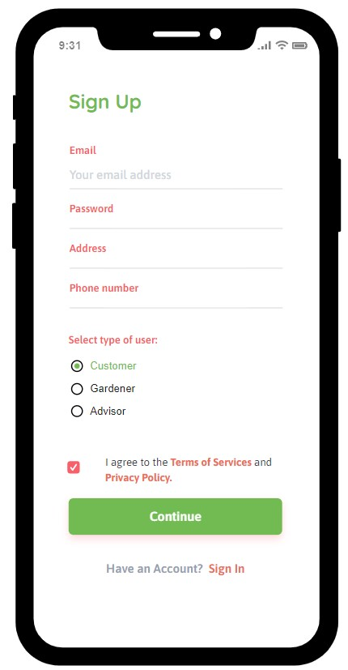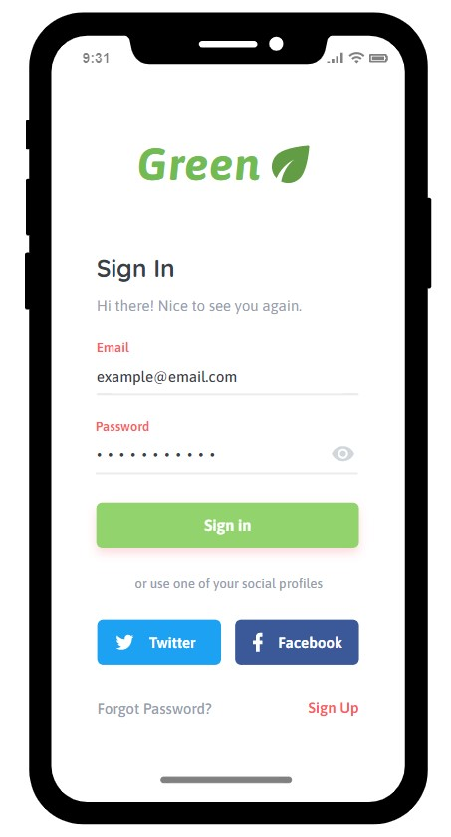**Login & Sign up.**

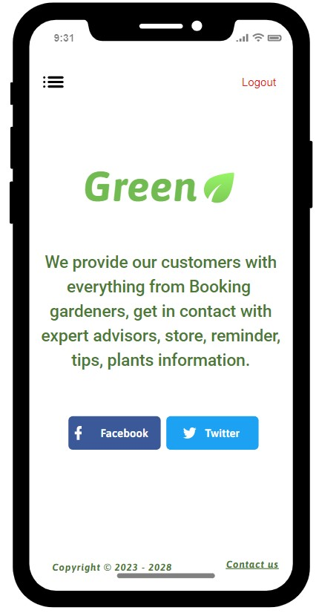**Home page & Menu.** **View Bookings.**

**Reminder page.** **Products.** **Tips.**

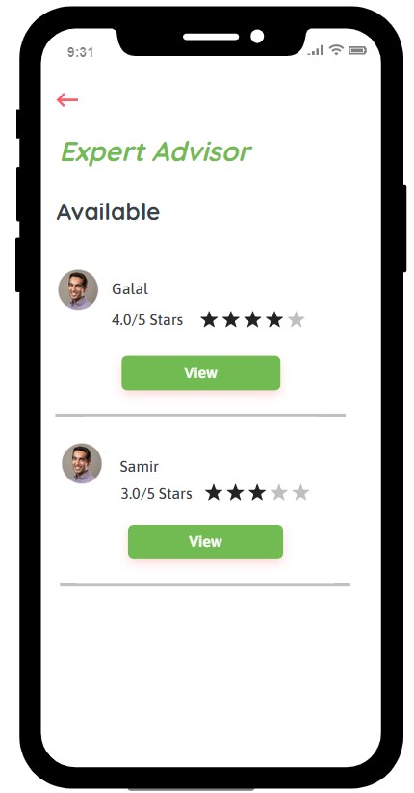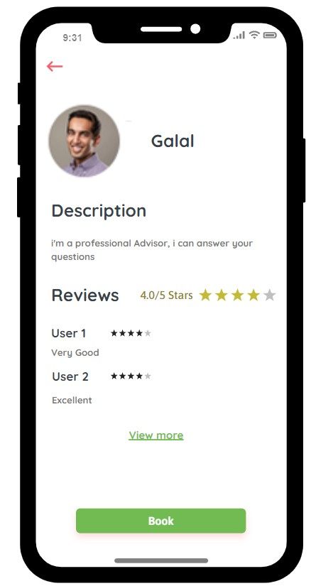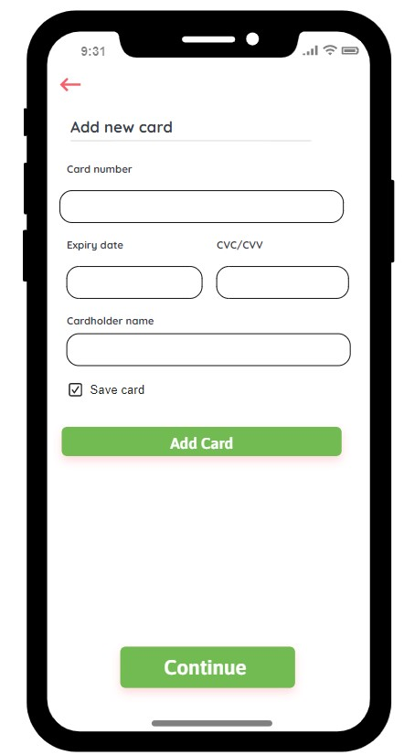**Booking Expert Advisor pages.**

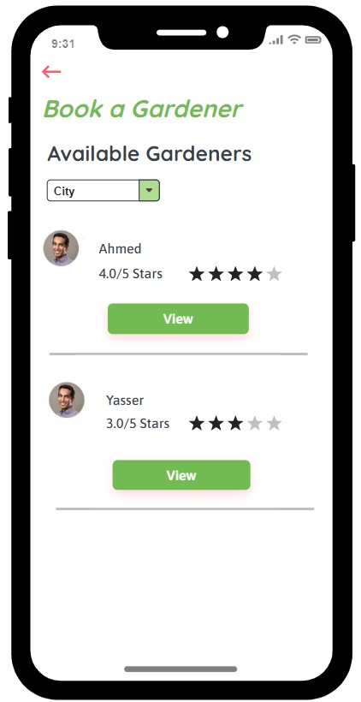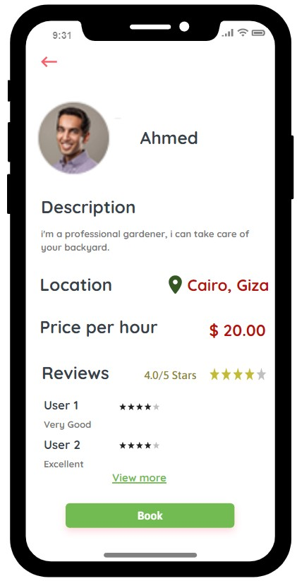**Booking Gardener pages.**

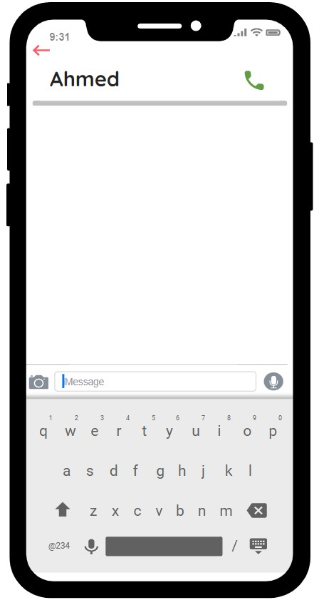

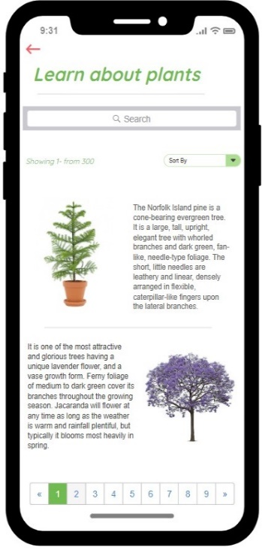**Learn about plants. Manage Profile.** **Expert** **Advisor pages**

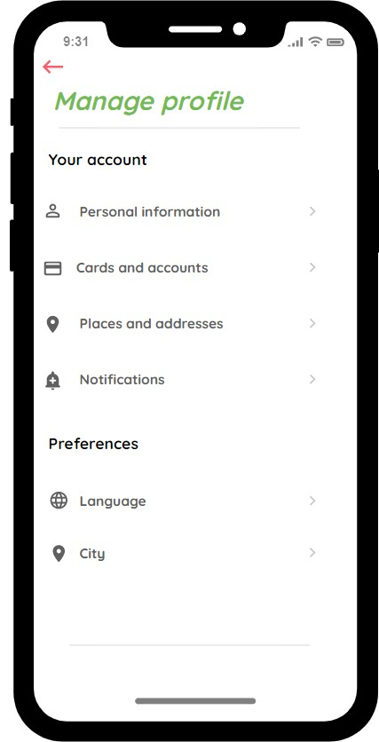

**Gardener**  **pages**. **Admin Panel.**

## **4.2 Tools & Techniques**

* Flutter and Dart
* Firebase
* Flask (python)
* SQL Server
* Lucid Chart
* Star UML
* Figma
* Moqups
* Drawio
* Android Studio
* VS Code

# **Chapter 5 Conclusions and Future Work**

## **5.1 Conclusions**

* In conclusion, the Green project aims to provide a comprehensive solution to the gardening industry. By leveraging the power of technology, we aim to make it easier for gardeners, customers, and experts to connect and collaborate.
* The platform offers a range of features, including booking gardeners, requesting expert advice, and purchasing gardening & eco-friendly products. Additionally, the platform incorporates several important functionalities such as secure payment processing, ratings and integration with third-party services.
* We believe the Green project has the potential to revolutionize the gardening industry.

## **5.2 Future Work**

* Community Collaboration.
* To-Do List.
* Plant Identifier.